Technical Report for ABON GROUPS
1. Introduction
Purpose
This report presents a comprehensive analysis of employee attrition at ABON GROUPS. The purpose is to understand workforce dynamics, identify key drivers of employee turnover, and support data-driven human resource decision-making.
Objective of the Project
The primary objective of this project is to analyze employee attrition patterns across departments, age groups, gender, education fields, and job roles in order to identify critical factors influencing employee turnover and workforce stability.
Problem Being Addressed
ABON GROUPS is experiencing a noticeable level of employee attrition. Without proper analysis, this attrition may lead to productivity loss, increased recruitment costs, and operational inefficiencies. The project seeks to answer the question:
Which employee segments contribute most to attrition, and why?
Key Datasets and Methodologies
- Datasets Used:
  - Employee demographic data
  - Department and job role data
  - Attrition records
  - Job satisfaction ratings
- Methodologies Employed:
  - Tableau calculation and KPI used
  - Calculated fields and percentages
  - Dashboard visualization techniques

3. Story of Data
Data Source
The dataset was obtained from ABON GROUPS’ internal Human Resources records, representing historical employee and attrition data.
Data Collection Process
Data was collected through internal HR systems and exported into Microsoft Excel for analysis. The process involved consolidating employee records, attrition status, and satisfaction survey responses.
Data Structure
- Rows: Individual employees
- Columns:
  - Employee ID
  - Age
  - Gender
  - Department
  - Job Role
  - Education Field
  - Attrition Status
  - Job Satisfaction Rating
Important Features and Their Significance
- Department & Job Role: Helps identify high-risk functional areas
- Age Group: Reveals career-stage attrition patterns
- Gender: Supports diversity and inclusion analysis
- Education Field: Highlights skills with higher turnover risk
- Job Satisfaction Rating: Indicates employee engagement levels
Data Limitations or Biases
- Job satisfaction is subjective and self-reported
- Attrition reasons are not explicitly captured
- External labor market conditions are not included

4. Data Splitting and Preprocessing
Data Cleaning
- Duplicate employee records were removed
- Incorrect or inconsistent department names were standardized
- Attrition values were converted into binary indicators (Yes/No)
Handling Missing Values
- Records with critical missing values were excluded
- Non-critical missing fields were handled using Excel functions such as IF, ISBLANK, and AVERAGE
Data Transformations
- Age was grouped into predefined ranges (Under 25, 25–34, etc.)
- Attrition rate percentages were calculated
- New calculated fields were created using Pivot Tables
Data Splitting
- Dependent Variable: Attrition status
- Independent Variables: Age, gender, department, education, job role, satisfaction rating
Industry Context
The analysis belongs to the Human Resources and Workforce Analytics domain, relevant across corporate and organizational management industries.
Stakeholders
- Human Resources Department
- Senior Management
- Department Heads
- Workforce Planning Teams
Value to the Industry
The insights help organizations reduce turnover, improve employee engagement, and optimize talent retention strategies.

5. Pre-Analysis
Identify Key Trends
- Higher attrition observed among younger employees (25–34)
- R&D and Sales departments show higher attrition contributions
Potential Correlations
- Lower job satisfaction appears linked to higher attrition
- Specialized education fields show increased turnover
Initial Insights
- Early-career professionals are more mobile
- High-demand skill roles experience stronger external competition

6. In-Analysis
Unconfirmed Insights
- Employees in R&D roles may be leaving due to workload pressure
- Sales attrition may be influenced by performance targets
Recommendations
- Improve career development programs
- Introduce targeted retention incentives
- Enhance job satisfaction initiatives
Analysis Techniques Used in Excel
- Pivot Tables and Pivot Charts
- Percentage and calculated fields
- Slicers for dynamic filtering
- Conditional formatting

7. Post-Analysis and Insights
Key Findings
- Overall attrition rate stands at 16.12%
- R&D (56.12%) and Sales (38.82%) contribute most to attrition
- 25–34 age group has the highest attrition count
- Male employees show higher attrition than females
Comparison with Initial Findings
Initial assumptions about younger employee turnover were validated. However, the scale of attrition in R&D was higher than expected.

8. Data Visualizations & Charts
Charts and Graphs
- Department-wise attrition pie chart
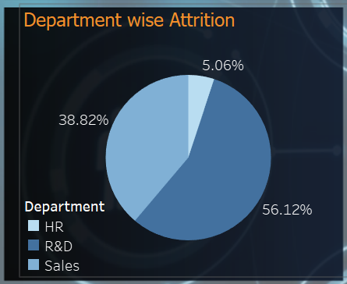
This departmental attrition shows that the organization is losing more people from R&D with over 56.12% as against sales and HR seeing this there is a need to look into what is the root cause of the mass exist in the organization and then to try solve it.
- Age group employee distribution bar chart
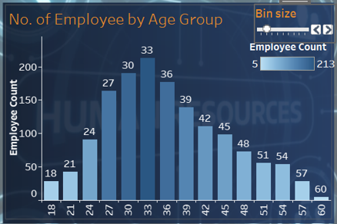
The Age group of employee distribution here shows that there are more people within the ages of 24+ to 45. This tells us that there is a productive age range in the organization and if maintained, can produced greater level of expertise in the organization, therefore more effort should be made in keeping this trend as the life line of the organization may be dependent on it. Also, from the chart, there is a possibility that the attrition in the large number of staff of the organization falls within the expertise rank, giving rise to questions of job satisfaction and the health of the working environment.

- Gender-based attrition comparison
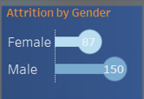
From the distribution we are seeing, we find out that Male tends to move from the organization than females giving room to questions like what is the leading cause of this migration and what can be done to stop or atleast causion the effect.
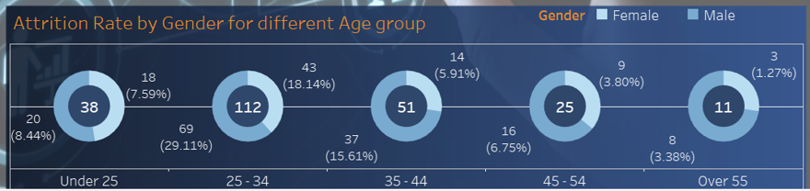
From the aggregated distribution above the chart then shows that the largest % of the people leaving the organization falls within the ages of 25 to 34 majority and with 69% of them been male which further brings the question of the work ethics with respect to male and female gender and the demand for their skills in different organization’s, as a result the attrition we are seeing here.
- Educational field attrition bar chart
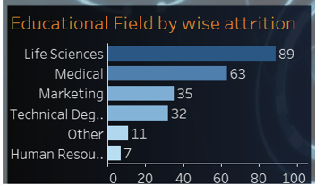
There are more people in Life Sciences and Medical field leaving, however you should not neglect the fact that the is a growing attrition in the marketing field also because their leaving has a direct impact on the growth of the business and the organsation as a whole.

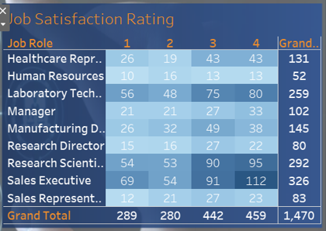
This shows the distribution of Job satisfaction, it is now clear from here why there are attrition in some of the fields this is because most of the job roles the people there are not satisfied with their roles and this is telling the rating and also the action of this job satisfaction is seen in the number of people wanting the leave the organisations. It is clear that over 16.12% of the employee are leaving the organsation which is a very high number and at this rate there is a possible that at every 8 years there will be a totally new and complete set of faces seen in the organization who will then be learning the organizational policy and culture only to leave again, this will give room to the organization spending more on recruitment, training, and others than the need to because of the attrition. Therefore conscious effort is needed to keep them.
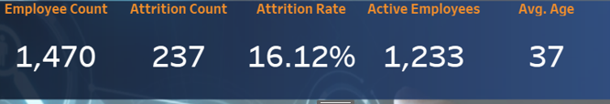
Dashboard
A centralized Excel dashboard was created to display KPIs such as:
- Total employees
- Attrition count and rate
- Active employees
- Average age

9. Recommendations and Observations
Actionable Insights
- Focus retention strategies on R&D and Sales departments
- Introduce mentorship programs for 25–34 age group
- Improve job satisfaction through recognition and growth opportunities
Optimizations or Business Decisions
- Review compensation structures for high-demand skills
- Strengthen internal mobility and career progression
Unexpected Outcomes
The relatively low attrition in HR compared to other departments was unexpected and suggests effective internal engagement practices.

10. Conclusion
Key Learnings
This analysis demonstrates that employee attrition at ABON GROUPS is influenced by age, department, job role, and satisfaction levels.
Limitations
- Lack of qualitative attrition reasons
- No external market comparison
- Time-bound dataset
Future Research
- Include exit interview data
- Analyze compensation and performance metrics
- Develop predictive attrition models

11. References & Appendices
References
- ABON GROUPS Internal HR Dataset
- Kaggle.com
- Workforce Analytics Best Practices Literature
Appendices
- Detailed Pivot Tables
- Tableau
- Expanded dashboard screenshots

